Step 1: Install Miniconda

<https://docs.anaconda.com/free/miniconda/index.html>

Pick either the Mac or PC download option and run the file.

Step 2: Make sure it works

* Open Miniconda and run the ‘conda’ command to make sure that it is installed.
  + You should see the following.

Step 3: Create a new environment for the course.

User guide to help: <https://conda.io/projects/conda/en/latest/user-guide/getting-started.html>

* Run ‘conda create -n CS5330’

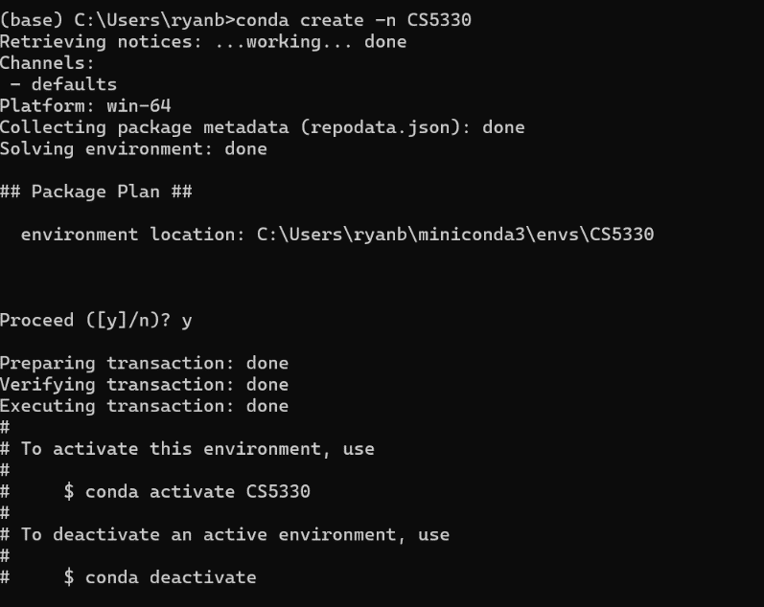

Step 4: Change working environments.

* Run ‘conda activate CS5330’
  + You should see that you change from the ‘base’ environment to the 'CS5330’ environment.

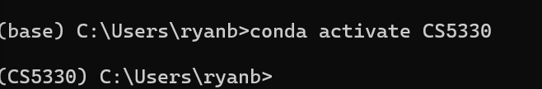

Step 5: install Python Libraries that will be used during this course.

* Run the following:
  + ‘conda install matplotlib’
  + ‘conda install numpy’
  + ‘conda install pandas’
  + ‘conda install opencv’

Step 6: open IDLE

* Run ‘IDLE’
  + This will be what we will programing in for the course.

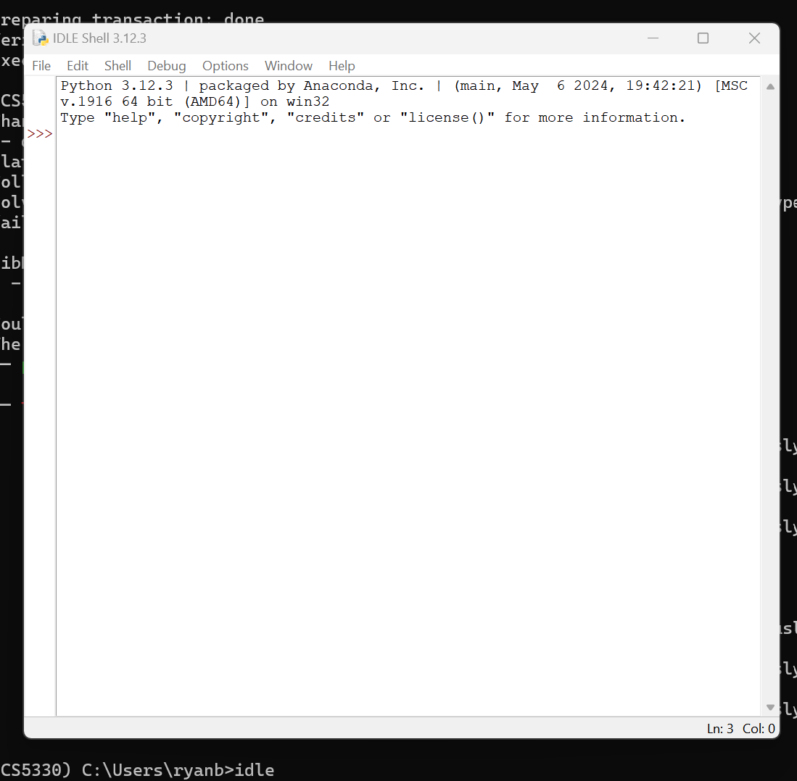

* Step 7: create a new file and test libraires.
  + In the IDLE shell go to file -> new file
  + Should open a blank ‘untitled’ python file.
  + Import the following libraries into your python file and run it:
  + If everything is installed correctly you shouldn’t see any errors.
  + * **I had issues installing OpenCV with conda. Others do not. For me, it installed the library but was unable find the library when importing it.**
    - **Solution that worked for me: run ‘pip install opencv-python’ in conda instead of ‘conda install opencv’**

Step 8: open an image with opencv

* Download ‘testimage1.png’ from canvas -> files -> images
* Upload the image to a local file that you can access with python
  + The image should be either in the same folder as your python file or in a folder that is relatively close to make calling the image easier.
* In your python file add the following code to open the image
  + I created a new file called ‘images’ that I uploaded the image to
  + Your path might be different. (we will go over this in class if you are having issues)

img = cv2.imread('images/testimage1.png', 0)#enter the local file path to where you uploaded the image to open it. Mine in in a folder called ‘images’

cv2.imshow('image',img)

* If everything works you should see the image open on your computer.

